# COVID 19

**WEAKENED HUMAN IMMUNITY FOR AMERICAN**



**AWS Marketplace deployed**

**Do Expired medicines contaminants in the American water supply, affect weakened human immunity for American and cause the Spread for Covid-19**

WHY IS SUFFERING MORE THAN ANY COUNTRY

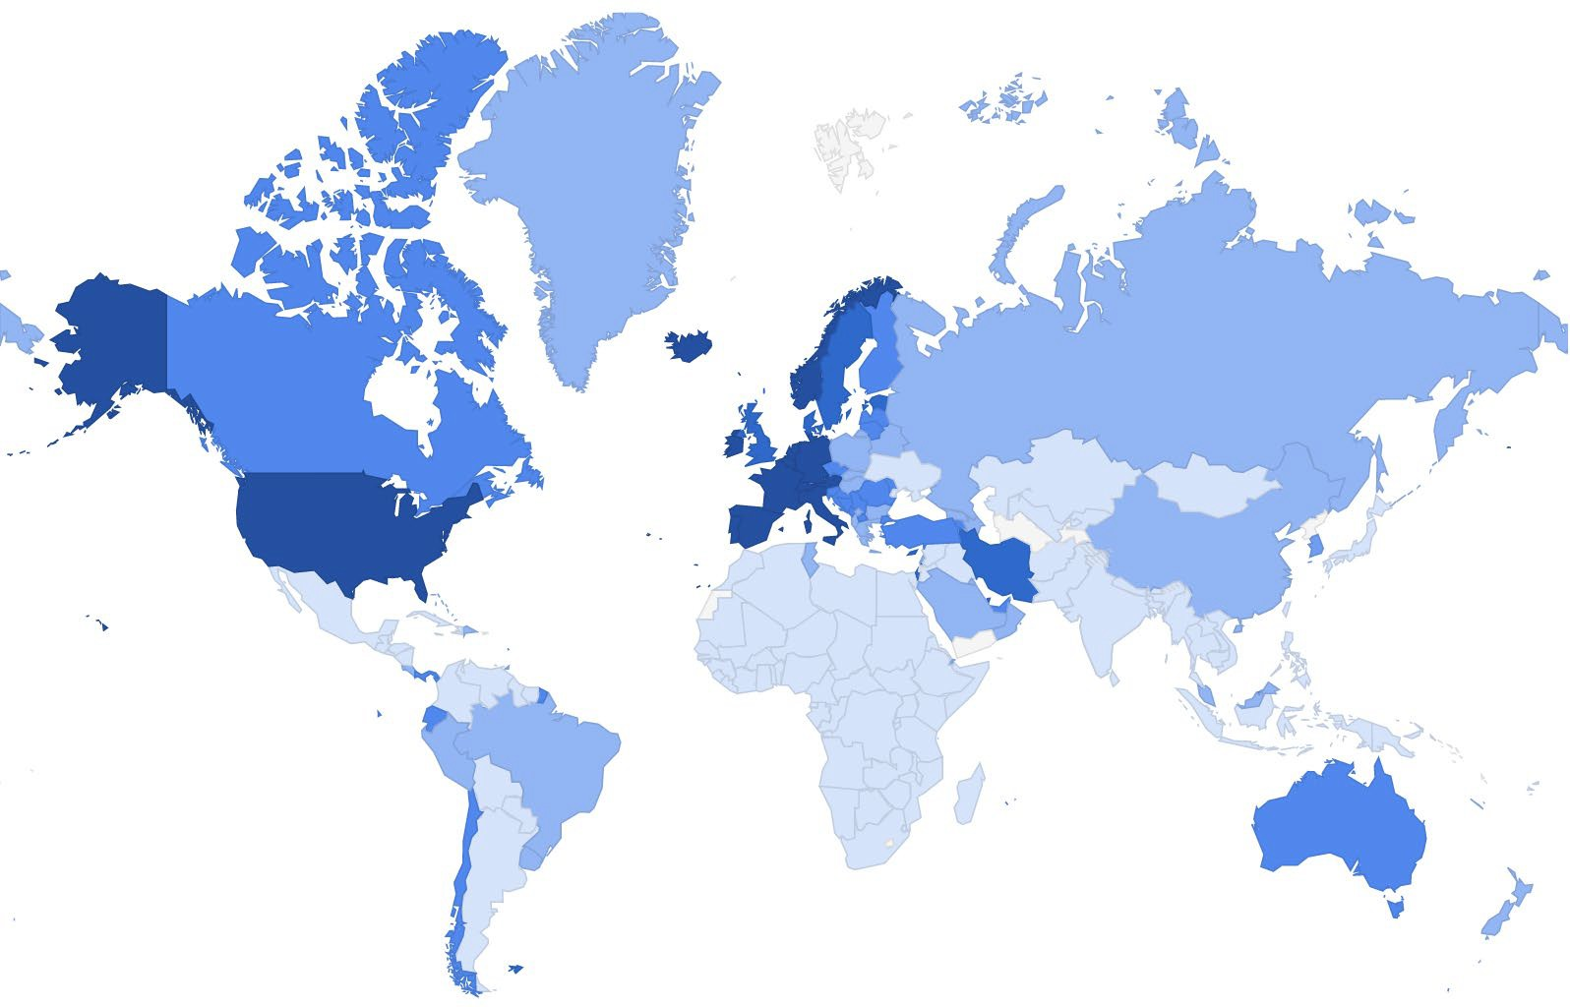

|  |  |  |  |
| --- | --- | --- | --- |
| United States | C 624,048 | R 50,947 | D 27,787 |

## Contaminants in the American Water Supply

Improperly discarded prescription medications are a growing threat to America’s water supply. In South Carolina, **128 million prescriptions filled every year**, and about **40 percent** of them result in unneeded medicine thrown away

**Antibiotic-resistant bacteria** already cause about **65,000 deaths per year**, and that number could rise if proper medication disposal techniques are not followed well and safe

**The problem:**

Pharmacies and hospitals, the pile of expired drugs they are required to toss out add up to about

**$200,000 per hospital** each year.

When you count the costs of expired medications that thrown away by pharmacies and consumers, at least **$1 billion worth of drugs destroyed each year**. There’s a lot of waste in any hospital system,” noted Dr. Robert Pedowitz, DO, medical director of the Family Practice of CentraState in New Jersey. “From multi-use bottles used once and packages that are never opened, there’s so much we waste on a daily basis based on the expiration date and not because we know that it’s definitely not still good.”

https://[www.healthline.com/health-news/your-](http://www.healthline.com/health-news/your-) prescription-expiration-date-might-be-inaccurate#1

## The solution to the Problem:

### My solution is to minimize the Expiration using Predictable formula and historical usage statistics

And using machine learning

“We using Predictable formula and historical data for product consumes to predict when our product will reach zero balance in inventory and we compare the expire date we generated from our formula to the actually expired date written in our product In that point, we will have the market status for our product to show two way a good or bad status

When customers get bad status in its product, they will have the chance to contact other pharmacies with good status to exchange the product with them

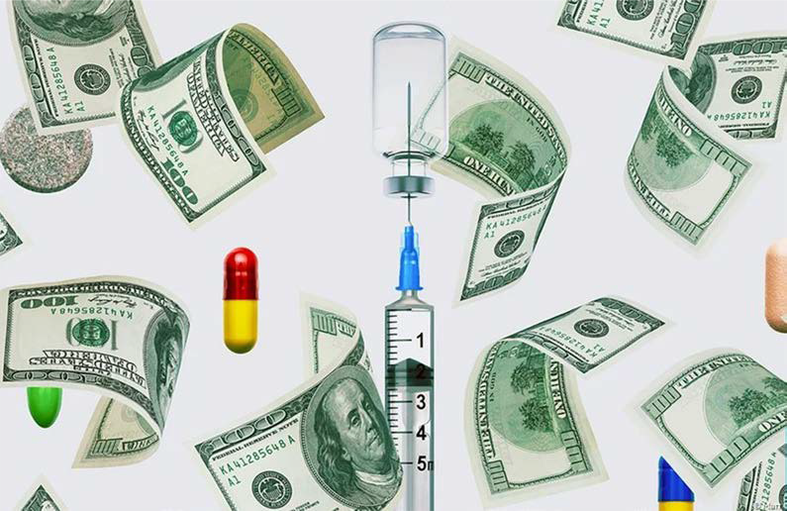

2019

**Expired Medicines, How To Avoid Their Financial Losses**

Abdelrazek Youssef Rizk

https://documentcloud.adobe.com/link/track?uri=urn%3Aaa id%3Ascds%3AUS%3Ac1ac18d0-25df-42ef-b4a2- 51c5ba1c8b13

https://github.com/abdelrazekrizk/MARKET-STATUS https://github.com/abdelrazekrizk/USCARE https://github.com/abdelrazekrizk/predict-the-end-of-the- expiration

https://github.com/abdelrazekrizk/Product-in-markets-status